# Live Sports, Piracy and Uncertainty: Understanding Illegal Streaming Aggregation Platforms

# Florian Hoof

## Geoblocked in Australia

Experiencing live football without having access to live TV coverage can be exceptionally thrilling – even though it might not be the preferred way to watch a match. On the sixth of May 2002, just after midnight, I was sitting nervously in a run-down internet cafe in Potts Point, Sydney, Australia. I was not here to watch a Champions League game, but was hoping to follow a football drama that unfolded live back in Germany’s second division. My club VfL Bochum, Germany’s most boring football team, had a chance to make it into the first division and one goal could make all the difference. As a fan of this rather insignificant team, I followed the score via live text ticker on a German sports web page.

Several circumstances brought me to this internet cafe. In 2002 options for accessing live football coverage were scarce. There was no way to live-stream the match. Of course in an era of analogue television, there were no digital live images available. Even if there were, the bandwidth provided by a 56k dial-up modem could not cope with that amount of data anyway. At that time TV coverage of German Bundesliga football in Australia was available only via the multicultural public broadcaster, SBS (the Special Broadcasting Service). They broadcast the German news every Sunday morning as a service for the German immigrant community in Australia, but only the highlights would have been shown, and with a one-week delay. There might have been the option to access live coverage via the satellite service Sky Sports Australia – but in that case I would have needed to find a sports bar that would turn their screens to a German second-division football match. This seemed unlikely in a country obsessed with Australian Rules Football, rugby and cricket, and I might have ended up having no access to the match at all. So as I was completely geoblocked from live TV coverage, I was forced to sit in front of a grey monitor, operating a dirty mouse that was sitting on an even dirtier mouse pad, pushing the reload button of the live ticker hoping that VfL Bochum would prevail.

In 2002 geoblocking was not an optional digital rights management feature that could be imposed on a given ‘information good’,[1] in this case a German football match. It was inherent in the materiality of the situation I found myself in, as a result of geographic, cultural and infrastructural circumstances that could not be circumvented – at least not with the resources available to me. Of course, circumstances have changed dramatically since then.[2] Digital video broadcasting has become the new standard and the broadcast television industry is struggling to adapt to this changed environment. Bandwidth is no longer only a restricting factor but, due to advances in video compression, has turned into a negotiable and scalable question of image resolution and quality. Furthermore, a whole array of different options for viewing live sports events has evolved. Now the German branch of Sky Sports has an app and a pay-tv subscription plan (Sky Go), allowing you to follow every match of Germany’s second division on your computer, tablet or mobile phone.

Despite these advances, if I wanted to watch a VfL Bochum match in Australia today, I would still struggle. Six matches per week of Germany’s first division are broadcast by beIN SPORTS Australia, a subsidiary of the Al Jazeera Media Network, but there is still no live coverage of the second division. Furthermore, all the aforementioned Sky Sports live-streaming services are geoblocked in Australia. There is still no legal way for Australians to access live sports coverage from Germany’s second division. However, if we move beyond live sports coverage provided by legal distribution channels a wide range of informal options are available which did not exist in 2002.

If in Australia today, I would most likely end up in front of a laptop or tablet in my apartment watching illegal live streams that can easily be accessed via streaming aggregation platforms such as Rojadirecta.meand Stream2watch.me. I might even be tempted to ask friends back in Germany to stream this live broadcast to me via a live-streaming service such as Periscope. For the consumer or sports fan, the increased availability of illegal distribution channels significantly changes the viewing situation. Information about these illegal options including the legal and security risks involved is widespread, with pay-TV circumvention practices discussed openly in mainstream newspapers, such as the Munich-based *tz*.[3] Illegal live sport streams are not exact copies of the authorized live experience. Offered for free, they deliver a highly unstable live experience, one that may disappear unexpectedly mid-match, and with noticeably poor image quality. Moreover, structures and mechanisms – such as legal measures or technological circumstances – that affect the availability of these streams remain an inaccessible black box to the user. As a result, the user is confronted by an uncertain situation that they cannot control or manage. Thus, even though such streams are literally ‘for free’ they also involve costs for the user precisely because of their unreliability.

## Illegal Live Sport Streams as ‘Digital Lemons’

I am specifically interested in understanding these costs and how they relate to consumers and market structures. Therefore, I analyze how quality, instability and uncertainty affect markets for digital information goods by focusing on live sports consumption via illegal streaming aggregation platforms. To theorize the productivity of uncertainty for digital network markets, I combine media and social theory with information economics. I use the concept of ‘lemons’, originally established by information economics to understand uncertainty in the market for used cars.[4] It describes the situation of a buyer with insufficient information about the quality of a vehicle he is offered by the car dealer. This used car might be a bargain but could also turn out to be a lemon – a product that is actually overpriced due to hidden quality deficiencies. The latter results in costs to the buyer as he pays more than normal market prices would indicate. The mechanisms at play can be transferred to the case of live sport streaming. In both cases uncertainty relates to – if not restricted to a purely monetary definition – additional costs for the user or consumer.

My framework specifically focuses on the costs that accrue to users in the process of locating, accessing and watching illegal information goods and services without knowing if the resource is a ‘digital lemon’. I use this term to refer to poor quality streaming sites, often containing malware, and offering an unreliable and unstable streaming resource – one which could carry legal implications for the user. In the same way that the term lemon is used to describe uncertainty and quality in the market for used cars, a ‘digital lemon’ is a sport stream of poor or uncertain quality.

Sports broadcasting is well suited to an analysis of the ‘digital lemons’ phenomenon because of its inherent liveness.[5] Unlike music or movies, which have a much longer commodity lifespan, live sports cannot be replicated through classical forms of piracy – such as recording and circulating copies after the match – because its value will have diminished greatly after the final score is known. Consequently, illegal sport streams are more likely to be affected by the phenomenon of ‘digital lemons’. While reproducible information goods can simply be downloaded and stored for later consumption, a dysfunctional live stream poses a much higher risk. If a stream is disrupted due to a technological failure or a copyright takedown request, there are limited options to switch to a legal source. Because of the non-reproducible liveness of sports events, the individual will face costs that are fundamentally different when compared to downloading music or movies. This makes live sports events an extremely valuable resource for content providers. From a theoretical point of view, the high-risk characteristics of ‘live’ information goods make them a suitable case to study the relations between quality and uncertainty in digital markets.

### Legal Risks versus Illegal Uncertainty

Following a legal live ticker in an internet cafe and watching illegal live streams at home are both connected to uncertainty and risks that might interrupt the user experience of ‘liveness’. In 2002 my live text ticker experience was disrupted because the owner of the internet cafe started to intentionally walk around my desk and began to shut down all the computers around me. As I was the only customer left, he was desperate to close his shop and get some sleep. This posed a serious but measurable risk to my live sports experience. I had plenty of information at hand to grasp the character of the situation and to develop strategies for dealing with it. One option to manage the evolving risk would be to talk to the owner of the internet café, asking him not to shut down my computer. Legitimate channels of distribution such as pay TV offer information goods characterized by a predictable stability in the user experience. To pay for such a subscription plan or to try to start a conversation with the owner of the internet cafe are both risk strategies to lower the probability of a disrupted live experience.

When it comes to live-streaming, this risk emerges in a different way. As it is not visible to the consumer it cannot be turned into a manageable risk strategy. Instead it remains uncertain and unpredictable. In order to comfortably access live football streams consumers rely on live stream aggregation platforms that compile a vast amount of live streaming channels. By systemizing them and making them visible, they provide easy access to these kinds of illegal resources. Platforms such as Stream2watch.me (Fig. 1) provide different categories of live sport events on their starting page. These broad categories can be filtered by country or league. After selecting a certain live sports event a submenu appears (Fig. 2), listing the diverse live streams available. The streams are sorted by resolution, quality, data transfer rate, and language of the commentary.

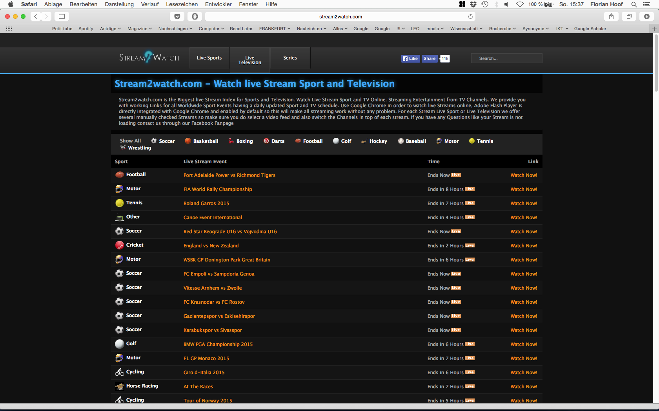

Fig. 1. Categories displayed on the starting page of the streaming aggregation platform Stream2watch.me.

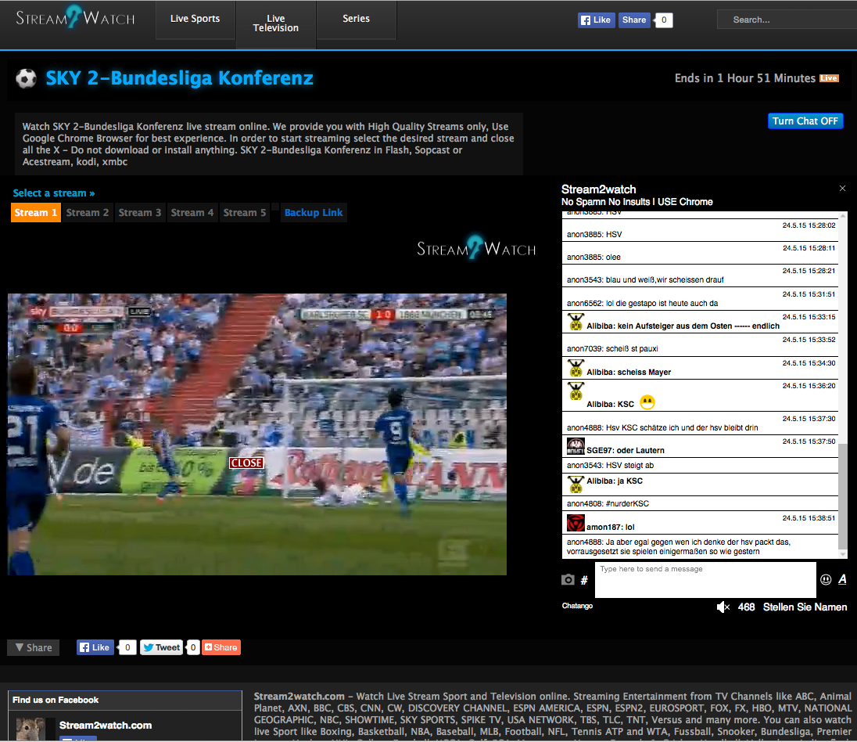

Fig. 2. Live stream selection submenu of a streaming aggregation platform.



Fig. 3. Variable quality, freezing and signal disruption are persistent risks when live-streaming sport.

Streams available for the German Bundesliga are either pirated coverage from the German branch of Sky Sports or from foreign broadcasters based in India, Russia, Italy, Spain, United States or China. Some streams are simply filmed from someone’s computer or television screen, while others directly access the original digital stream. Depending on the design of the platform and the available streams, between three and fifteen streams are typically listed per match. Popular matches that involve clubs with a worldwide fan base such as FC Bayern Munich tend to attract a larger number of streams. However the quality of these streams is quite diverse, ranging from high-definition resolution to low-quality, heavily compressed video in which it is often difficult to recognize the players. Blurring and compression marks are often visible, making it hard to follow the match (Fig. 3). In addition, streaming channels that infringe the intellectual property of Sky Sports Germany are often disconnected in the last third of a 90-minute football match, reflecting the time it takes to send and process takedown notices. Streams based on foreign broadcast channels are normally not affected by takedown notices. URLs for streaming aggregation platforms change frequently, and platforms often disappear then reappear with a slightly different address.



Fig. 4. Malware is a common security hazard people have to negotiate when using streaming platforms

There is also the risk that there are no streams available at all, or that the quality is too low. Previously stable, high-quality streams can turn into dysfunctional broadcasts if too many users are trying to access them. Other dangers relate to the diverse business models adopted by the streaming providers. Some operators generate profits as part of the ‘grey’ advertising market and utilize live streaming as an advertising platform, displaying multiple ads via popup windows or Flash content. Others utilize streaming channels as landing pages to spread malware, enabling them to extend bot-networks, conduct identity theft or commit credit card fraud. They use false plug-ins, updates or video player software installers; prepare hidden, transparent buttons; operate with Javascript-based drive-by-download attacks; or take advantage of security holes in software such as Flash (Fig. 4). Consumers that rely on illegal live streams significantly increase their risk of being affected by such attacks.

While many people argue that digital network markets are new forms of collaborative capitalism, which can provide free goods, the case of live sports streaming demonstrates that there are significant costs involved. The whole process of locating and consuming illegal ‘live’ information goods has to be understood as a risky investment of resources that is continuously affected by the problem of ‘lemons’. The prevailing uncertainty is a result of different aspects that constitute information goods as ‘digital lemons’:

1. *search ability* (via well-known streaming platforms; by links that suddenly appear in social networks).

2*.* *accessibility* (via browser, video player software or via specific software packages; skills required to access streams).

3. *image and sound quality* (compression artifacts; image resolution; time lag issues; foreign language commentaries; loudness; sound modulation).

4. *stability* and *reliability* (interruption of streams due to copyright issues, bandwidth issues or technical problems).

5. *security hazards* (caused by malware and viruses while using illegal streaming platforms).

## Conclusion: Uncertain Information Goods and Digital Network Markets

A better understanding of the relations between uncertainty, risk and the consumer provides for a more precise analysis of contemporary digital markets characterized by the phenomenon of piracy as well as by ‘freemium’ or free-service business models. Live streaming, because of the increased risk of ‘digital lemons’, offers an exemplary case to investigate uncertainty on the consumer side. Here, the heterogeneous relations between piracy and legitimate consumption structure the gray area between scarcity and abundance of live information goods. The market oscillates between paid and free content and is characterized by information asymmetries that relate to quality and uncertainty. These dynamic structures are not bound to a technologically determined idea of network media that automatically turn goods into public goods. Piracy and measures taken against it – such as geoblocking – are part of continuously fought ‘battles and dramas between formal and informal, the ill structured and the well structured, the standardized and the wild’.[6] Here, consumers move continuously ‘back-and-forth between ill structured and well structured’[7] situations. If not restricted to the idea of ‘free’, ‘convergence’ or ‘access’, to dualisms such as ‘formal’ versus ‘informal’ or ‘legal’ versus ‘illegal’, these continuous negotiations between infrastructure, information goods and the market can be understood as a *modus operandi* that structures, stabilizes and changes digital markets. Focusing on the productivity of uncertainty and risk enables us to open up the black box of copy and access culture and to situate it as an intrinsic part of those markets. But it also connects piracy and circumvention practices to a broader perspective that uses risks and uncertainty to explain how stability and change operate in society.[8]

## References

Akerlof, G.A. ‘The Market for “Lemons”: Quality Uncertainty and the Market Mechanism’, *Quarterly Journal of Economics* 84.3 (1970): 488-500.

Beck, Ulrich. *Risk Society. Towards a New Modernity*. London: Sage, 1992.

Couldry, Nick. ‘Liveness, “Reality”, and the Mediated Habitus from Television to the Mobile Phone’, *Communication Review* 7.4 (2004): 353-361.

Curtin, Michael, Jennifer Holt, and Kevin Sanson (eds) *Distribution Revolution: Conversations about the Digital Future of Film and Television*, Berkley: University of California Press, 2014.

Feuer, J. ‘The Concept of Live Television: Ontology as Ideology’, in E.A. Kaplan (ed.) *Regarding Television: Critical Approaches - An Anthology*, Los Angeles: American Film Institute, 1983, pp. 12-21.

Giddens, Anthony. ‘Risk and Responsibility’, *Modern Law Review* 62.1 (1999): 1-10.

Hutter, Michael. ‘Information Goods’, in R. Towse and Edward Elgar (eds) *A Handbook of Cultural Economics,* Cheltenham, 2006, pp. 263-268.

Levine, E. ‘Distinguishing Television. The Changing Meanings of Television Liveness’, *Media, Culture & Society* 30.3 (2008): 393-409.

Luhmann, Niklas. *Risk. A Sociological Theory*, Berlin/New York: De Gruyter, 1993.

Star, Susan L. ‘This Is Not a Boundary Object: Reflections on the Origin of a Concept’, *Science, Technology and Human Values* 35.5 (2010): 601-617.

tz. ‘Hier sehen Sie Borussia Dortmund gegen FK Krasnodar jetzt im TV und Live-Stream’, 17 September 2015, https://www.tz.de/sport/fussball/europa-league-borussia-dortmund-gegen-fk-krasnodar-tv-live-stream-sky-sport1-5515199.html/.

1. Michael Hutter, ‘Information Goods’, in Ruth Towse (ed.), *A Handbook of Cultural Economics,* Cheltenham: Edward Elgar, 2006, pp. 263-268.
2. See, for example, Michael Curtin, Jennifer Holt, and Kevin Sanson (eds), *Distribution Revolution: Conversations about the Digital Future of Film and Television*, Berkley: University of California Press, 2014.
3. See: Sophie Rohringer, ‘Hier sehen Sie Borussia Dortmund gegen FK Krasnodar jetzt im TV und Live-Stream’, *tz*, 30 September 2015, https://www.tz.de/sport/fussball/europa-league-borussia-dortmund-gegen-fk-krasnodar-tv-live-stream-sky-sport1-5515199.html.
4. G. A. Akerlof, ‘The Market for “Lemons”: Quality Uncertainty and the Market Mechanism’, *Quarterly Journal of Economics* 84.3 (1970): 488-500.
5. Nick Couldry, ‘Liveness, “Reality”, and the Mediated Habitus from Television to the Mobile Phone’, *Communication Review* 7.4 (2004): 353-361.; Elena Levine, ‘Distinguishing Television. The Changing Meanings of Television Liveness’, *Media, Culture & Society* 30.3 (2008): 393-409; Jane Feuer, ‘The Concept of Live Television: Ontology as Ideology’, in E.A. Kaplan (ed.), *Regarding Television: Critical Approaches – An Anthology*, Los Angeles: American Film Institute, 1983, pp. 12-21.
6. Susan L. Star, ‘This Is Not a Boundary Object: Reflections on the Origin of a Concept’, *Science, Technology and Human Values* 35.5 (2010): 601-617, p. 614.
7. Star, ‘This Is Not a Boundary Object’, p. 614.
8. See: Ulrich Beck, *Risk Society. Towards a New Modernity*, London: Sage, 1992; Anthony Giddens, ‘Risk and Responsibility’, *Modern Law Review* 62.1 (1999): 1-10; Niklas Luhmann, *Risk. A Sociological Theory*, Berlin/New York: De Gruyter, 1993.